NATIONAL FEDERATION OF YOUNG FARMERS’ CLUBS
Final
July 2026
Area Eliminator
Amended 18.8.2026

Competitions Programme 2026 - 2027
NFYFC LADIES Netball
16 to 28 years
R U L E S
COMPETITION AIM
To encourage YFC members to work together as a team to demonstrate their Netball skills in a competition environment.

LEARNING OUTCOMES
Netball skills: throwing, catching, agility, footwork, shooting, hand-eye-coordination and tactical decision making; teamwork, respect, discipline, enjoyment, sportsmanship as well as providing health and wellbeing benefits.
REMINDER: Read in conjunction with NFYFC General Rules. Further information can be found at http://www.nfyfc.org.uk/CompetitionsResources/competitionsresources

- VENUE
  - After Area Finals, the National Final will be held at Sports Day on Sunday, 4th July 2027 in Staffordshire. Amended 18.8.2026 – to Sunday 27th June 2027.

- REPRESENTATION
  - Counties may enter one competitor per 600 members or part thereof.
  - Areas will be represented in the Final by one competitor per 3,000 members or part thereof. (Northern Area 2, Eastern Area 1, East Midlands 1, West Midlands Area 1, South West Area 2, South East Area 1 and Wales 2)

- ELIGIBILITY
  - A squad of 9 members, 7 of those players must be on the court at any one time. All players must be aged between 16 years and over and 28 years and under on 1st September 2026 (this age range must be adhered to) and full members of a Club affiliated to NFYFC. This means competitors have attained their 16th birthday on 1st September 2026 and may be 29 on the day of the national final.

- SUBSTITUTION
  - If 4 of the original squad members are unable to go forward to subsequent rounds, then the next highest placed team will represent the Area.
  - Rule 1 – Substitution Eligibility
For Area Competitions progressing to the NFYFC Finals, if 50% or more members of the original team are unable to compete in the next round, the place will be offered to the next highest scoring team or individual from the previous round.
  - Rule 2 – Deadline for Team Changes
For Area Competitions progressing to the NFYFC Finals, any changes to team members must be made no later than 7 days prior to the competition. This requirement will be included in the 2026/2027 competition rules.
- Procedure

"All matches shall be played in accordance with the World Netball Rules of the Game and England Netball's Domestic Guidance in force in England at the time of the competition, except where specifically stated within these Competition Regulations."
  - Each position has a main role to play:
Goal Shooter (GS) - To score goals and to work in and around the circle with the GA
Goal Attack (GA) - To feed and work with GS and to score goals
Wing Attack (WA) - To feed the circle players giving them shooting opportunities
Centre (C) - To take the Centre Pass and to link the defence and the attack
Wing Defence (WD) - To look for interceptions and to prevent the WA from feeding the circle
Goal Defence (GD) - To win the ball and reduce the effectiveness of the GA
Goalkeeper (GK) - To work with the GD and to prevent the GS from scoring goals

  - Each playing position has a specific area of the court in which to play:
Goal Shooter | GS | Area 1,2
Goal Attack | GA | Area 1,2,3
Wing Attack | WA | Area 2, 3
Centre | C | Area 2,3,4
Wing Defence | WD | Area 3,4
Goal Defence | GD | Area 3,4,5
Goalkeeper | GK | Area 4,5
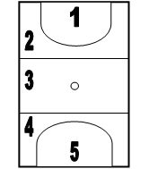

  - Starting or Restarting the Game
    - Centre passes are taken alternately by the player undertaking the Centre Role, after a goal has been scored. All players must start in the goal thirds except the two Centre Roles. The Centre in possession of the ball stands with at least one foot wholly within the centre circle.
    - When the whistle is blown to start play, the Centre in possession of the ball may step outside the centre circle but must obey the footwork rule. If when the whistle was blown:
(a) Only one foot was wholly inside the centre circle, this foot will be considered the ‘landing foot’
(b) Both feet were wholly inside the centre circle, the foot not moved first will be considered the ‘landing foot’.
    - The opposing Centre stands anywhere within the Centre Third, is free to move and can mark the ball but must be 90cm (3ft) away. The Centre pass must be caught or touched by a player in or landing in or jumping from a stance in the Centre third.
  - Playing the Ball
    - A player who has caught or the ball shall play it or shoot for goal within three seconds
    - A player may bounce or bat the ball once to gain control
    - Once released, the ball must next be touched by another player. If player has control of the ball and then drops it, they must not pick it back up. This is replaying.
    - There must be room for a third player between hands of thrower and catcher
    - A player on the ground must stand up, observing the footwork rules, before playing ball.
  - Footwork
    - Having caught the ball, a player may land or stand on:
    - One foot - while the landing foot remains grounded, the second foot may be moved anywhere any number of times, pivoting on the landing foot if desired. Once the landing foot is lifted, it must not be re-grounded until the ball is released.
    - Two feet (simultaneously) - once one foot is moved, the other is considered to be the landing foot, as above.
    - Hopping or dragging the landing foot is not allowed.

  - Scoring a Goal
    - Only GS or GA can score - they must be completely within the shooting circle (within Areas 1 or 5) when the ball is received in order to shoot for goal.

  - Toss up
    - This is administered for all simultaneous infringements. The two players stand facing each other at their own shooting ends with hands by their sides and the umpire flicks the ball upwards not more than 60cm (2ft) in the air as the whistle is blown. The distance between the players shall be 90cm (3ft).
    - A FREE PASS is awarded for infringement of any of the preceding rules. It may be taken by any player allowed in that area, as soon as they have taken up a stationary position. If it is decided that another player would be better taking it, the ball must be placed back on the floor- the ball should not be handed over as this counts as a pass. (A player may not shoot from a free pass in the shooting circle).
  - Obstruction
    - Player with ball: the nearer foot of the defender must be 90cm (3ft) from the landing foot of the player with the ball, or the spot where the first foot had landed if one has been lifted. The defender may jump to intercept or defend the ball from this 90cm (3ft) distance.
    - Player without ball: the defender may be close, but not touching, providing that no effort is made to intercept or defend the ball and there is no interference with the opponents throwing or shooting action. Arms must be in a natural position, not outstretched, and no other part of the body or legs may be used to hamper an opponent.
    - Intimidation: of any kind, is classed as obstruction. E.g. marking opponent’s eyes instead of ball.
    - A standing player is not compelled to move to allow an opponent a free run, but dangerous play must be discouraged, e.g. moving into the landing space of a player already in the air or stepping late into the path of a moving player.
  - Contact
    - When attacking, defending or playing the ball, opposing players may come into physical contact with each other. Provided the players do not interfere with each other’s play or use their bodies to gain an unfair advantage over their opponent, it is deemed to be ‘contest’ and play continues. ‘Contact’ occurs when a player’s actions interfere with an opponent’s play whether these are accidental or deliberate.
    - A Penalty is awarded for the above infringements taken from where the infringement occurred. The offending player must stand out of play (physically and verbally) beside the thrower until the pass or shot has been taken. Any opposing player allowed in that area may take the penalty.
    - A player who is correctly positioned to take a penalty may choose to play the ball before the sanction has been set. If the player chooses to play the ball immediately:
(a) The infringer may not take part in play until the ball has been released or make any attempt to intercept the penalty pass
(b) The penalty pass will be retaken if the infringer interferes with it.
  - Court Areas
    - Offside: Player moving out of their own area, with or without ball (on a line counts as within either area).
    - Over a Third: Ball may not be thrown over two transverse lines without being touched. A free pass shall be taken from the area where the ball crossed the second transverse line.
    - Out of Court: Ball is out of court when it contacts anything outside the court area (not the goalpost). The ball is returned into play by a Throw-In taken from a point outside the line where the ball left the court. The player stands with foot close to the line, and the ball must be thrown onto the court within three seconds. If toes are touching the line, this is a foul throw. All players must be on court before the ball is thrown.

  - Dress. All members of the team to wear matching dress and bibs indicating playing position. A set of spare bibs must also be available of different colours, which is to be supplied by the team.
  - Replacements.
    - Teams can make substitutions and/or team changes when play is stopped for injury or illness. There is no limit to how many substitutions can be made during the game. When time is called for an injury, the umpires will stop play. The player who has called time (time allowed 30 seconds) must leave the court to receive treatment on the side-line, and a replacement must be made for the injured player. For any injuries where blood is drawn, the player must leave the court; the ball and court must be cleaned before play starts and any stained clothing is to be replaced.
    - Please note that jewellery of any description or long nails are NOT allowed (nails must be short and smooth). Hair must be suitably tied back.
    - All matches will be played under the Rules laid down by England Netball and Welsh Netball (which is governed by the International Netball Federation).
    - At the NFYFC final a full-sized court will be used (30.5m by 15.25m), size 5 netball and posts to be at 3.05m (10ft).
    - At the NFYFC final each game will last for a minimum of 7 minutes each way with a direct change of ends after the 7 minutes. Substitutions may only occur during this half time change of ends.
    - The winner is determined by the team scoring the most points. A draw will be awarded if both teams have scored the same number of points at the end of the game.
    - League points will be awarded as follows: Win 3, Draw 2, Loss 1.

- AWARDS
  - Trophy and NFYFC Prize Card to the winner.
  - NFYFC Prize Cards to competitors placed 2nd, 3rd and 4th.
  - NFYFC Certificates of Achievement will be awarded to all competitors.

- NOTES
  - It is advised to have either St John Ambulance or The British Red Cross with an ambulance in attendance at both County and Area Rounds to minimise risk to members.
  - Referees must have a minimum FENA C Award (this applies to both England and Wales).
  - Further information for English Counties can be found at https://www.englandnetball.co.uk/ or by contacting your local Regional Coordinator. Details can be found by following the link https://www.englandnetball.co.uk/regions/ Welsh Counties can find further information at http://www.welshnetball.com/
  - Details on the England Netball rules can be found here: https://www.englandnetball.co.uk/make-the-game/officiating/rules-updates/ Details on the rules on the Welsh Netball website can be found here: http://www.welshnetball.com/inf-release-updated-rules-of-netball-for-2018/

Links to the relevant Rules:-
World Netball Federation Rules 2024 World-Netball-Rules-Book-2024.pdff
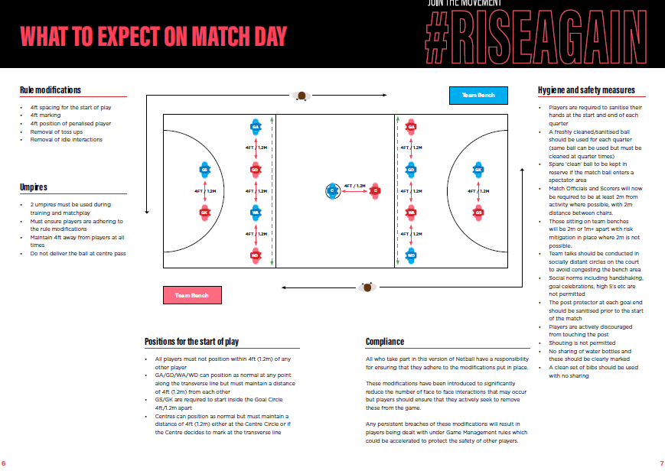
  - In conjunction with these rules please also see the document 20a entitled Netball 2026 Domestic Guidance

