Final
July 2026
Area Eliminator
Amended 18.8.2026

NATIONAL FEDERATION OF YOUNG FARMERS’ CLUBS

Competitions Programme 2026-2027
NFYFC Auctioneering
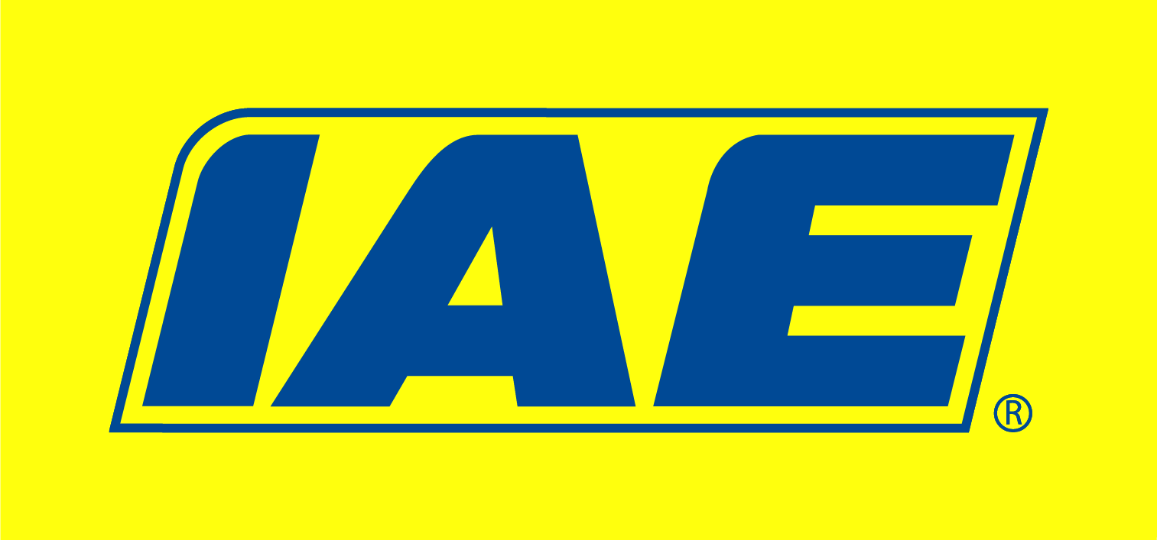
28 & Under
R U L E S
COMPETITION AIM
To encourage YFC members aged 28 and under to demonstrate their valuation and auctioneering skills in a competitive environment.

LEARNING OUTCOMES
Knowledge of subject/items, auctioneering, valuation, communication, clarity and audibility skills

REMINDER: Please read these rules in conjunction with NFYFC General Rules and familiarise all competitors with the Fine System in place for withdrawal from competitions.
Further information can be found at https://nfyfc.org.uk/competition-organisers-resources

- VENUE
  - After Area Finals, the National Final will be held at the Competitions Day on Saturday 3rd July 2027 at the County Showground Stafford. Amended 18.8.2026 – to Saturday 26th June 2027.

- REPRESENTATION
  - Counties may enter one competitor per 600 members or part thereof.
  - Areas will be represented in the Final by one competitor per 3,000 members or part thereof. (Northern Area 2, Eastern Area 1 and East Midlands 1, West Midlands Area 1, South West Area 2, South East Area 1 and Wales 2)

- ELIGIBILITY
  - Competitors must be 28 years of age or under on 1st September 2026 and full members of a Club affiliated to the NFYFC.

- SUBSTITUTION
  - If the competitor through to the National Final must withdraw from the competition, then the next highest placed competitor will represent the Area.
  - All substitutes must have been eligible to compete in the County Final.
Rule 1 – Substitution Eligibility
For Area Competitions progressing to the NFYFC Finals, if 50% or more members of the original team are unable to compete in the next round, the place will be offered to the next highest scoring team or individual from the previous round.
Rule 2 – Deadline for Team Changes
For Area Competitions progressing to the NFYFC Finals, any changes to team members must be made no later than 7 days prior to the competition. This requirement will be included in the 2026/2027 competition rules.
- PROCEDURE
  - Each Competitor will be required to auction 3 lots.
  - Prior to the auction commencing the competitor will view a total of 6 Lots which will include agricultural and non-agricultural items.
  - The Competitor will then have 20 minutes to draft a handwritten, catalogue-style description and provide a valuation figure for each Lot on the day of the competition.
  - The competitor is to hand their descriptions and valuations to the judge prior to the auction. The competitor will then choose 3 Lots at random ‘out of a hat’ from the 6 available, to sell.
  - The judge will identify one of the Lots to have a reserve. The item and price of the reserve lot is at the judge’s discretion.
  - The competitor should provide an introduction and then open the auction sale, outlining the procedure and relevant conditions of the sale e.g. the payment process, order of the auction, buyer’s commission rate.
  - Competitors at the NFYFC Final will not be eligible to watch other competitors until after they have competed.
  - Stewards will be placed in the audience to act as purchasers on the lots to ensure there is enough bidding to enable the competitor to demonstrate the skill. These stewards will be anonymous to the competitor and will only bid if no other bids are forthcoming.
  - Stewards will have no knowledge of the item’s values provided by the competitor.
  - Once all the lots have been ‘sold’ the auctioneer will close the auction in a suitable way and the judge will work out their score.

- Scale of Marks & penalties
Lot description & valuation 20
Opening & closing commentary 20
Auctioneering skill 40
Auction conduct and practice 20

Total 100

- Awards
  - Trophy and a NFYFC Prize Card to the winning competitor.
  - NFYFC Awards and a Prize Card to competitors placed 2nd and 3rd.
  - A special Award will be presented to the highest scoring member who is 21 and under on the day of the final.
  - NFYFC Certificates of Achievement will be awarded to individuals participating in the NFYFC Final.

