NATIONAL FEDERATION OF YOUNG FARMERS’ CLUBS
Direct Entry
Final
July 2026
Competitions Programme 2026-2027

NFYFC Beef Live & Carcase Judging
21 & Under and 28 & Under

R U L E S
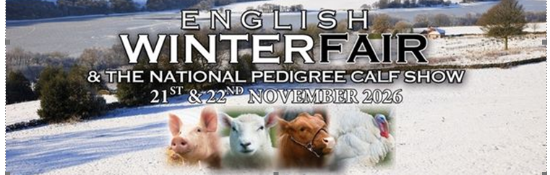
Competition Aim
To provide members with the opportunity to put their training to the test by judging high quality livestock and carcases and presenting their findings to industry experts. Members are provided with constructive feedback and advice from the industry experts for their future development.

Learning outcomes
Judging skills including: observation, understanding of the make-up of the animal and market demands. Communication skills, presentation skills and time keeping.
REMINDER: Please read these rules in conjunction with NFYFC General Rules and familiarise all competitors with the Fine System in place for withdrawal from competitions.
Further information can be found at https://nfyfc.org.uk/competition-organisers-resources
- DATE & VENUE
  - After the County Final, the National Final will be held at the English Winter Fair, Staffordshire Showground on Saturday 21st and Sunday 22nd November 2026. Exact timetable to be confirmed.
- REPRESENTATION
  - Counties may enter two teams per 600 members or part thereof in the National Final.
- ELIGIBILITY
  - A team shall consist of two (2) members. One competitor must be 21 years of age or under and the second competitor must be 28 years of age or under on 1st September 2026 and full members of a Club affiliated to NFYFC.
- PROCEDURE
- Competitors will judge two groups of live cattle in Part I and two groups of beef carcases in Part II as follows:
  - Part I – Live
    - Place a group of four cattle in order of merit and estimate their classification according to the Meat & Livestock Commission Services Limited (MLCSL) Carcase Classification Scheme.
    - Place a group of four cattle in order of merit and give reasons for those placings
  - Part II - Carcase
    - Place a group of four beef carcases in order of merit and classify them according to the Meat & Livestock Commission Services Limited (MLCSL) Carcase Classification Scheme.
    - Place a group of four beef carcases in order of merit and give reasons for those placings.
  - The live animals and carcases will be designated A, B, X, Y
  - Competitors may handle the live cattle (this will depend on the venue and facilities), but only in such a way that they do not cause bruising. Excessive handling after a caution from the stewards will result in disqualification.
  - The handling of carcases is NOT ALLOWED.
  - Judging in both rings will operate simultaneously.
  - In the carcase judging section, competitors may arrive at their placing by using the following scale of marks as an aid:
Conformation
Shape of buttock 10
Thickness of rump/loin 15
Depth and area of eye muscle 10
Shape of forequarter 10
Thickness of shoulder area 5
(Neat, compact, blending well with f¼)
Colour/quality and texture of lean 10
(E.g., fine, coarse grain, bright “cherry” red marbling)

Fat

Distribution of fat throughout carcase 10

Amount of fat over eye muscle 15

Amount of fat over brisket 5

Colour, quality and texture of fat 10

(E.g., white/creamy/yellow/firm/oily)

Total 100

TIMING
  - Live Assessment
  - Ten minutes judging (place & reasons) - handling allowed (in groups)
  - Five minutes judging (place only & classification) – handling allowed (in groups)
  - At least Five minutes preparing reasons before being called to the judge

  - Carcase Judging & Classification
  - Ten minutes judging (place & reasons) - handling allowed (in groups)
  - Five minutes judging (place only & classification) – handling allowed (in groups)
  - At least Five minutes preparing reasons before being called to the judge

  - Reasons
  - Up to two minutes will be allowed for each competitor to give his or her reasons to the Judge in both the live and carcase sections. Two marks will be deducted for each fifteen seconds (or part thereof) that a competitor goes over the allotted two minutes. The marks will be deducted from the competitor’s total.

- SCALE OF MARKS
  - Live Animals:
Placings: (on 2 rings = 2 x 50) 100
Correct estimated MLCSL Classification 50
Reasons: (on 1 ring) Accuracy of observations 25
Comparison 15
Style (including presentation of competitor) 10
LIVE TOTAL: Per Competitor 200

  - Carcases:
Placing: (on 2 rings = 2 x 50) 100
Correct MLCSL Classification 50
Reasons: (on 1 ring) Accuracy of observations 25
Comparison 15
Style (including presentation of competitor) 10
CARCASE TOTAL: Per Competitor 200
TOTAL: Per Competitor 400
TOTAL: Per Team 800
- AWARDS
  - English Winter Fair Trophy, Prize Card and Prize Money from Kerbl/Rutland Fencing.
  - Winter Fair prize card to 2nd and 3rd place.
  - NFYFC Certificates of Achievement will be awarded to all competitors.

- NOTES
  - During the competition, competitors may not have with them any papers or literature other than the placing cards provided.
  - When stating reasons, competitors may use only the NOTES SECTION on the official cards provided. These notes are intended for reference only and the competitors who read their notes verbatim to the Judges will be penalised.
  - Mobile phones are not to be used once the competition has started – if found to be using them this will be an automatic disqualification.
  - Competitors in the NFYFC competitions are not eligible to take part in the Staffordshire and Birmingham Agricultural Society competition on the Sunday.
  - During the period of the competition, competitors must not communicate directly or indirectly with any person other than Judges and Stewards under penalty of disqualification.
  - IMPORTANT: Competitors are reminded to read carefully the General Rules relating to National Competitions if they are taking part in this Competition. These are available from the NFYFC website
  - Members will be disqualified if they are not at the Presentation of Awards without prior permission being granted.
  - Competitors must provide themselves with white coats, which must be worn during the period of the competition and at the Presentation of Awards, Club, County and Sponsor logs are permitted on either the front or back of the coats.

