NATIONAL FEDERATION OF YOUNG FARMERS’ CLUBS
Final
July 2026
Area Eliminator
Amended 18.8.2026

Competition Programme 2026-2027

NFYFC Fence Erecting

R U L E S
Competition Aim
To provide an opportunity for members to demonstrate the acquired skill in building stock proof fence in a competitive environment.

Learning outcomes
A knowledge of planning and building of a stock proof fence using practical skills in fence erecting, budgeting for materials, acquiring materials, use of hand tools and teamwork.

REMINDER: Please read these rules in conjunction with NFYFC General Rules and familiarise all competitors with the Fine System in place for withdrawal from competitions.
Further information can be found at https://nfyfc.org.uk/competition-organisers-resources

- DATE & VENUE
  - After Area Finals, the National Final will be held at NFYFC Competitions Day on Saturday, 3rd July 2027 at the County Showground, Stafford. Amended 18.8.2026 – to Saturday 26th June 2027.

- REPRESENTATION
  - Counties may enter one team per 600 members or part thereof in Area Finals.
  - Areas will be represented in the final by one team per 3,000 members or part thereof. (Northern Area 2, Eastern Area 1, East Midlands Area 1, West Midlands Area 1, South West Area 2, South East Area 1 and Wales 2)

- ELIGIBILITY
  - A team shall consist of three (3) members 28 years of age or under on 1st September 2026, and full members of a Club affiliated to the NFYFC.

- SUBSTITUTION
  - If two or more of the original team are unable to go forward to subsequent rounds, then the next highest placed team will represent the Area.
  - All substitutes must have been eligible to compete in the County Final.
Rule 1 – Substitution Eligibility
For Area Competitions progressing to the NFYFC Finals, if 50% or more members of the original team are unable to compete in the next round, the place will be offered to the next highest scoring team or individual from the previous round.
Rule 2 – Deadline for Team Changes
For Area Competitions progressing to the NFYFC Finals, any changes to team members must be made no later than 7 days prior to the competition. This requirement will be included in the 2026/2027 competition rules.

HEALTH & SAFETY – ESSENTIAL READING/ACTION FOR ALL COMPETITORS
- It is essential that all competitors read the Health and Safety Executive’s guidance paper concerning fencing and note is taken of the safe working practices and protective clothing equipment that is recommended.

- PROCEDURE
  - At the NFYFC Final the team will be required to erect a stock proof boundary fence using the materials provided, as illustrated in the diagram.
  - The team are required to prepare a written risk assessment/method statement, which is to be handed to the Chief Steward on the day of the competition - prior to the competition start. Failure to provide a written risk assessment/method statement or failure to comply with it; or working unsafely, will result in immediate disqualification. Please see NFYFC Fence Erecting Risk Assessment Template below. This may be used and completed as teams wish (Risk 1 already entered as an example).
  - The fence shall be in a straight line for 30 metres.
    - The height from the ground to the tensile wire is 75mm (3”), tensile wire to net 75mm (3”), net 800mm (31.5”), net to top tensile wire 100mm (4”), overall height 1050 mm (41.5”).
    - The intermediate posts shall be at equal spacing.
  - It shall be constructed of post and netting with 1 strand of tensile wire below and 1 strand above the netting.
    - There shall be 1 strand of tensile wire 75mm (3”) above the ground, and the netting shall be 75mm (3”) above this.
    - There shall be 1 strand of tensile wire above the netting, set at 100mm (4”) above the top of the netting.
    - Netting and wire shall be secured to the end strainers using a recognised knot.
  - At one end of the fence there will be a box strainer assembly using a horizontal strut and diagonal brace wire as per diagram.
    - The box strainer shall be made with 2 x 2.4m (8’) strainer with a 2.4m (8’) 75-100mm (3”-4”) diameter horizontal brace, with tensile wire.
    - The horizontal brace shall be morticed into the strainers on both ends.
  - At the other end of the fence there should be a strainer with a diagonal strut.
    - The assembly shall be made using a 2.4m (8’) strainer and 2.4m (8’) angled strut, with the strut secured using a horizontal thrust block.
    - The strut must have a thrust plate at the end to prevent movement. The struts need to be left open for the judges to see.
    - The strut is to be morticed into the strainer at 450mm (18”) to the top of the strut – ie, between the 4th and 5th wire on the net.
    - A foot block needs to be attached to the strainer towards the bottom of the strainer on the opposite side to the strut.
  - Wire joints
    - All joints to be made during the competition. No joining aids will be permitted.
    - A join in the netting should be made by hand approximately in the middle of the length.
    - A join in the tensile wire approximately in the middle of the length must also be completed.

Diagram is not to scale and is for illustrative purposes only
All spacings to be determined by the competitors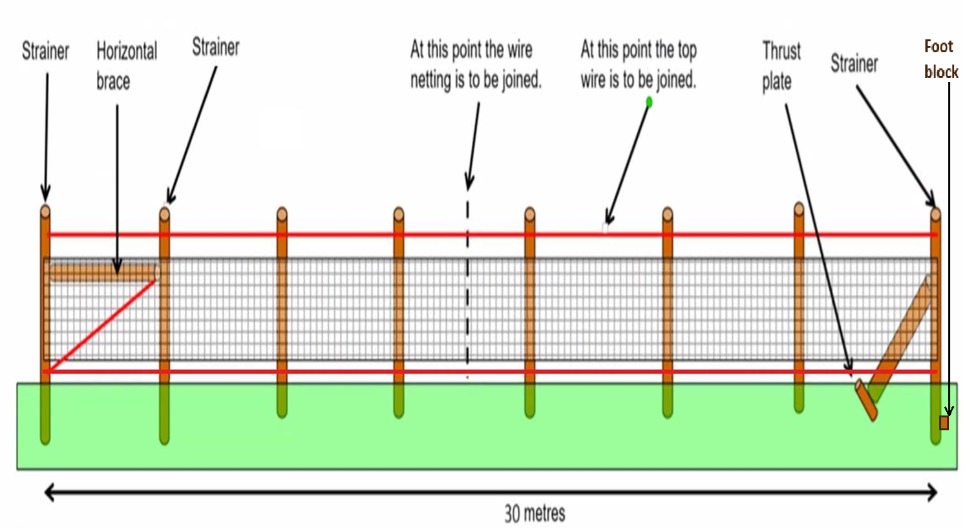

  - Only materials supplied by the organisers are to be used for Area and National Finals (see list of materials below).
  - Only hand tools will be allowed, and the teams themselves must provide these. No power tools or chainsaws are allowed.
    - All tools and equipment used must be fit for purpose and be in good condition, well maintained and safely operated by members of the team at all times. Judges/stewards have the right to stop the use of tool/piece of equipment if, in their view, it is not safe to use or is being handled/used in an unsafe manner.
  - Competitors are not allowed to shorten any of the vertical posts.
  - The Judge reserves the right to inspect any strut following completion of the task.
  - All teams are required to dismantle their fence after the Presentation of Awards (The thrust plate must be out of the ground).
  - Teams are required to clear away all debris and any off-cuts of wire etc must not be put down the postholes. Receptacles will be provided for this purpose. Soil will be available to make the ground good. Any team not complying with this ruling will be disqualified and receive a £75 fine.
  - The Judge’s decision is final.

- MATERIALS TO BE PROVIDED
3 x 2.4m (8ft) round pointed posts, 150-175mm (6” - 7”) diameter (strainers)
2 x 2.4m (8’) round posts, 75-100mm (3”- 4”) diameter (horizontal strut, diagonal strut)
5 x 1.65m (5’6”) round pointed posts, 75-100mm (3”- 4”) diameter (intermediates)
1 x chock (thrust plate) 1800mm x 125mm x 75mm (72” x 5” x 3”) to note that a piece needs to be cut-off to form the foot block from this piece
35 metres of X-Knot High Tensile FX8/80/22 wire netting
90 metres of high tensile wire
10 x nails 5mm x 150mm (6”) nails
Staples

- TIMING
  - For the NFYFC final will be 3 hours.
  - To note that once the time of 3 hours has been reached, teams will be asked to stop, and the fence will be judged as seen.
  - Please note that the tidying of tools and equipment away will be included in the time to complete the task.
- SCALE OF MARKS
Fixing end posts, strainer post, diagonal strut & box strainer | 30
Intermediate posts | 10
Overall neatness | 20
Fixing and tensioning of netting & plain wire | 25
Joint in netting and plain wire | 10
Written risk assessment | 5
TOTAL | 100

- AWARDS
  - NFYFC Fence Erecting Trophy and Prize Cards to the winning team.
  - NFYFC Prize Cards to teams placed 2nd and 3rd.
  - NFYFC Certificate of Achievement will be awarded to all members of teams in the NFYFC final.

NFYFC Fence Erecting – Risk Assessment Template

Item |  | Activity  (Description of activity and associated hazards) |  | Risk Evaluation  (No controls) |  |  |  |  |  | Safety precautions  (Details of preventative or control measure for each hazard) | Residual Risk Evaluation  (With Controls)
 |  |  |  | P |  | S |  | R |  |  | P | S | R
1 | Mild steel wire tensioned beyond breaking point causing eye damage |  | 3 |  | 4 |  | A |  | Wear suitable eye protection |  | 3 | 2 | C
2
3
4
5
6
7
8
9
10

Consequences
A; Hazard MUST be eliminated or avoided, work NOT to proceed.
B; Risk MUST be controlled by physical safeguards.
C; Risk MUST be controlled so far as is reasonably practicable.
#; Risk is adequately controlled / insignificant.
 | S1 | S2 | S3 | S4
P1 | # | # | # | C
P2 | # | # | C | B
P3 | # | C | B | A
P4 | # | B | A | A

Probability [P] Severity [S] Risk Level [R]
1; Improbable 1; Negligible
2; Remote 2; Minor
3; Possible 3: Severe
4; Probable 4: Extreme

